Student name: Hala Mahmoud Ismael Anaqweh
Student id: 202417250

SKILLS-BASED JOB MATCHING DATABASE

Executive Summary
Many skilled immigrants and refugees struggle to find work that matches their abilities. The main problem is simple: language barriers and different credential systems make it hard for them to show what they can really do. At the same time, employers miss out on talented workers because traditional hiring focuses too much on perfect English and local certificates.
The Problem: Qualified workers from other countries often can't prove their skills through normal job applications. Their training and experience get overlooked because they're described differently or in another language. Meanwhile, businesses need workers but can't find the right people through usual hiring methods.
the Solution: I built a job matching platform that connects immigrant and refugee workers with employers based on actual skills, not just paperwork. Here's how it works:
- Workers create profiles in their own language, listing what they can do and their experience
- The system translates and matches skills across different countries and credential systems
- Employers post jobs and get matched with workers who have the right abilities
- Matching happens based on real skills and experience, not just certificates or language level
- The platform recognizes that training from different countries is often equal to local training
How It Helps: This system makes job searching fair for everyone. Workers can show their true abilities without language stress. Employers find qualified people they would have missed before. The result is immigrants and refugees getting meaningful work while businesses fill their labor needs with motivated, experienced employees.
The platform turns wasted talent into productive employment by removing barriers that shouldn't matter in the first place.

Main Goals of the System
- Help immigrant and refugee workers find jobs that actually fit their skills and experience
- Let workers create profiles in Arabic so language isn't a barrier
- Recognize diplomas and training from different Arab countries like Palestine, Syria, and Lebanon
- Match people with jobs based on what they can do, not just paperwork or perfect English
- Help employers find talented Arab workers they'd normally miss
- Make hiring fair by focusing on skills, not where someone studied
- Lower unemployment for immigrants and refugees, especially those forced to leave home
- Give young Arabs better chances to find work in a tough job market
- Help skilled workers from Palestine, Syria, and Yemen get back on their feet
- Connect Arab countries that need workers with countries that have talented people looking for jobs

Identify the entities and attributes and draw an entity relationship diagram (ERD) for the system

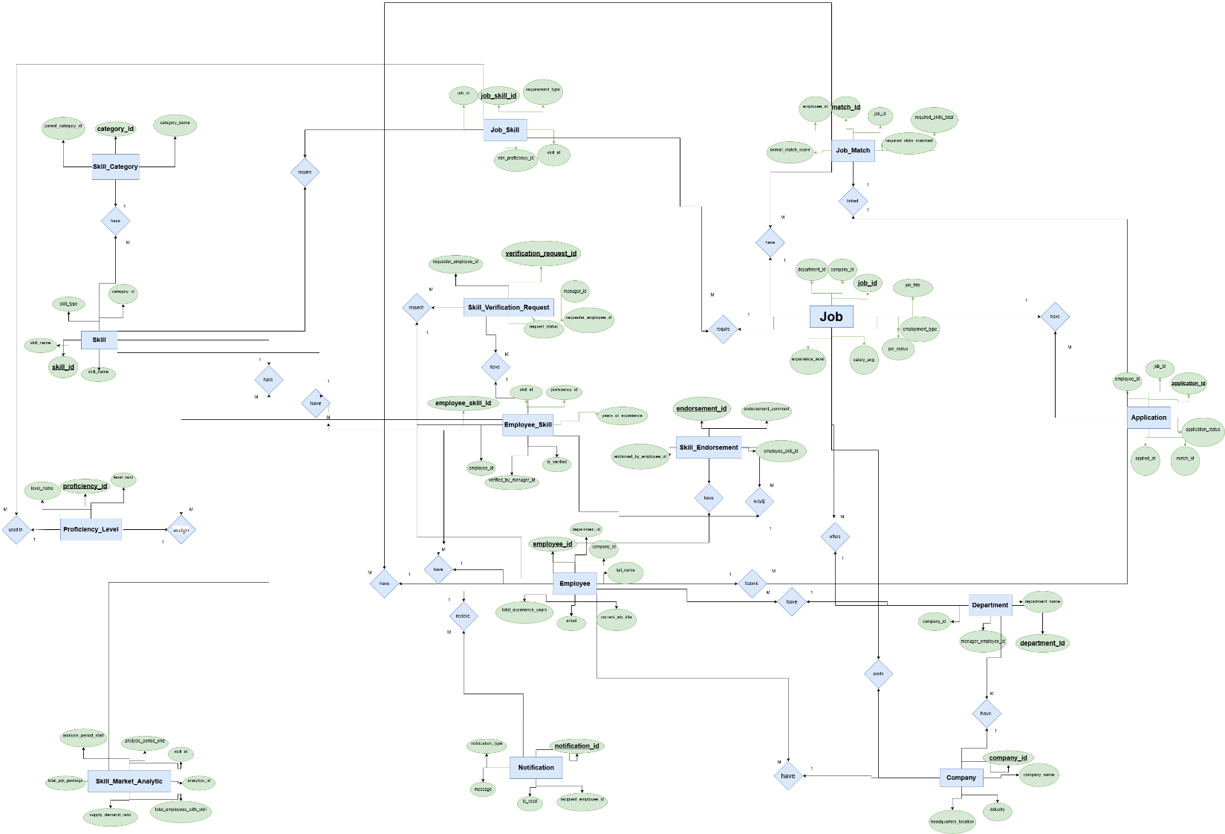

(2,3,4) section - Part II demonstrates the practical implementation of the Skills-Based Job Matching Database through three core tasks:
Table Creation: We create all 15 MySQL tables with comprehensive constraints including primary keys, foreign keys, check constraints, and unique constraints to ensure data integrity and enforce business rules.
Data Insertion: We populate each table with five sample records representing realistic data for companies, employees, skills, jobs, and their relationships.
Data Verification: We retrieve and display all inserted data using SELECT queries with screenshots to confirm successful implementation.
This implementation validates that my database design is functional, properly constrained, and ready to support the job matching platform for immigrant and refugee workers.

CREATE TABLE Company (
company_id INT PRIMARY KEY,
company_name VARCHAR(100) NOT NULL,
industry VARCHAR(100) NOT NULL,
headquarters_location VARCHAR(100) NOT NULL
);
INSERT INTO Company (company_id, company_name, industry, headquarters_location) VALUES
(1, 'Tech Innovations Ltd', 'Technology', 'San Francisco'),
(2, 'Green Energy Corp', 'Renewable Energy', 'Berlin'),
(3, 'MedLife Healthcare', 'Healthcare', 'London'),
(4, 'AutoDrive Motors', 'Automotive', 'Tokyo'),
(5, 'Global Finance Group', 'Financial Services', 'New York');
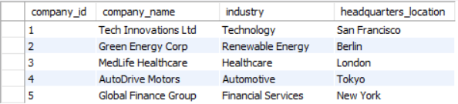
SELECT * FROM Company;
*the table contains much more rows , but I screen shotted the rows I have inserted in the code only

CREATE TABLE Department (
department_id INT PRIMARY KEY,
company_id INT NOT NULL,
department_name VARCHAR(100) NOT NULL,
manager_employee_id INT UNIQUE,
FOREIGN KEY (company_id) REFERENCES Company(company_id)
);
INSERT INTO Department (department_id, company_id, department_name, manager_employee_id) VALUES
(10, 1, 'Software Development', 101),
(20, 2, 'Project Management', 103),
(30, 3, 'Medical Analysis', 104),
(40, 4, 'Automotive Engineering', 105),
(50, 5, 'Financial Advisory', 102);
SELECT * FROM department;
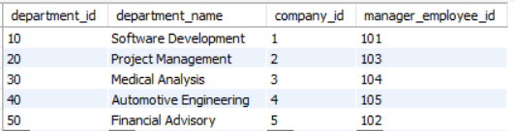

CREATE TABLE Employee (
employee_id INT PRIMARY KEY,
company_id INT NOT NULL,
department_id INT NOT NULL,
email VARCHAR(100) UNIQUE NOT NULL,
full_name VARCHAR(100) NOT NULL,
current_job_title VARCHAR(100),
total_experience_years INT CHECK (total_experience_years >= 0),
FOREIGN KEY (company_id) REFERENCES Company(company_id),
FOREIGN KEY (department_id) REFERENCES Department(department_id)
);
INSERT INTO Employee (employee_id, company_id, department_id, email, full_name, current_job_title, total_experience_years) VALUES
(101, 1, 10, 'john.doe@techinnovations.com', 'John Doe', 'Software Engineer', 5),
(102, 1, 10, 'jane.smith@techinnovations.com', 'Jane Smith', 'Senior Developer', 8),
(103, 2, 20, 'alex.green@greenenergy.com', 'Alex Green', 'Project Manager', 7),
(104, 3, 30, 'sarah.wong@medlife.com', 'Sarah Wong', 'Medical Analyst', 6),
(105, 4, 40, 'mike.tan@autodrive.com', 'Mike Tan', 'Automotive Engineer', 10);
SELECT * FROM Employee;
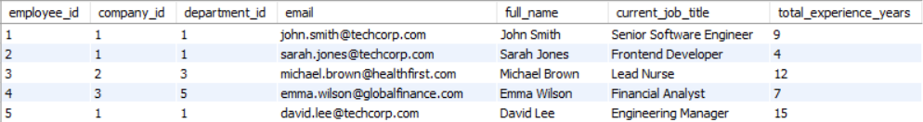

CREATE TABLE Skill_Category (
category_id INT PRIMARY KEY,
category_name VARCHAR(100) NOT NULL,
parent_category_id INT,
FOREIGN KEY (parent_category_id) REFERENCES Skill_Category(category_id)
);
INSERT INTO Skill_Category (category_id, category_name, parent_category_id) VALUES
(1, 'Technology', NULL),
(2, 'Programming', 1),
(3, 'Databases', 1),
(4, 'Healthcare', NULL),
(5, 'Clinical Skills', 4);
SELECT * FROM Skill_Category;
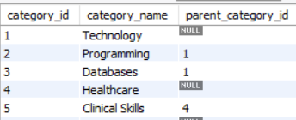

CREATE TABLE Skill (
skill_id INT PRIMARY KEY,
skill_name VARCHAR(100) NOT NULL,
category_id INT NOT NULL,
skill_type VARCHAR(50),
FOREIGN KEY (category_id) REFERENCES Skill_Category(category_id)
);
INSERT INTO Skill (skill_id, skill_name, category_id, skill_type) VALUES
(101, 'Python Programming', 2, 'Technical'),
(102, 'SQL', 3, 'Technical'),
(103, 'Project Management', 2, 'Professional'),
(104, 'Patient Care', 5, 'Clinical'),
(105, 'Data Analysis', 2, 'Technical');
SELECT * FROM Skill;
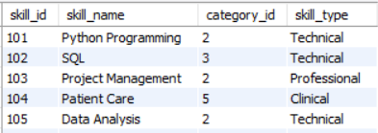

CREATE TABLE Proficiency_Level (
proficiency_id INT PRIMARY KEY,
level_name VARCHAR(50) NOT NULL,
level_rank INT NOT NULL CHECK (level_rank > 0)
);
INSERT INTO Proficiency_Level (proficiency_id, level_name, level_rank) VALUES
(1, 'Beginner', 1),
(2, 'Intermediate', 2),
(3, 'Advanced', 3),
(4, 'Expert', 4),
(5, 'Master', 5);
SELECT * FROM Proficiency_Level;
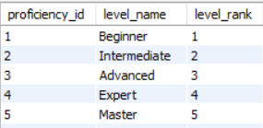

CREATE TABLE Employee_Skill (
employee_skill_id INT PRIMARY KEY,
employee_id INT NOT NULL,
skill_id INT NOT NULL,
proficiency_id INT NOT NULL,
years_of_experience INT CHECK (years_of_experience >= 0),
is_verified BOOLEAN DEFAULT FALSE,
verified_by_manager_id INT,
FOREIGN KEY (employee_id) REFERENCES Employee(employee_id),
FOREIGN KEY (skill_id) REFERENCES Skill(skill_id),
FOREIGN KEY (proficiency_id) REFERENCES Proficiency_Level(proficiency_id),
FOREIGN KEY (verified_by_manager_id) REFERENCES Employee(employee_id)
);
INSERT INTO Employee_Skill (employee_skill_id, employee_id, skill_id, proficiency_id, years_of_experience, is_verified, verified_by_manager_id) VALUES
(1, 101, 101, 3, 4, TRUE, 102),
(2, 101, 102, 2, 3, FALSE, NULL),
(3, 102, 103, 4, 6, TRUE, 101),
(4, 103, 101, 2, 2, TRUE, 102),
(5, 104, 104, 3, 5, TRUE, 103);
SELECT * FROM Employee_Skill;
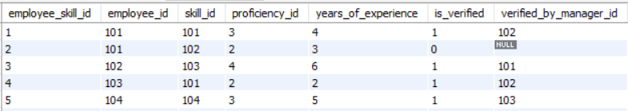

CREATE TABLE Skill_Endorsement (
endorsement_id INT PRIMARY KEY,
employee_skill_id INT NOT NULL,
endorsed_by_employee_id INT NOT NULL,
endorsement_comment VARCHAR(255),
FOREIGN KEY (employee_skill_id) REFERENCES Employee_Skill(employee_skill_id),
FOREIGN KEY (endorsed_by_employee_id) REFERENCES Employee(employee_id)
);
INSERT INTO Skill_Endorsement (endorsement_id, employee_skill_id, endorsed_by_employee_id, endorsement_comment) VALUES
(1, 1, 102, 'Excellent Python skills and problem-solving.'),
(2, 1, 103, 'Reliable and efficient in project delivery.'),
(3, 3, 101, 'Strong leadership and project management.'),
(4, 4, 104, 'Very skilled in Python and mentoring.'),
(5, 5, 103, 'Exceptional patient care and clinical knowledge.');
SELECT * FROM Skill_Endorsement;
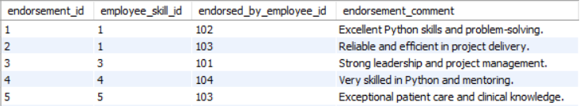

CREATE TABLE Job (
job_id INT PRIMARY KEY,
company_id INT NOT NULL,
department_id INT NOT NULL,
job_title VARCHAR(100) NOT NULL,
employment_type VARCHAR(50),
experience_level VARCHAR(50),
salary_min INT CHECK (salary_min >= 0),
salary_max INT CHECK (salary_max >= salary_min),
job_status VARCHAR(50),
FOREIGN KEY (company_id) REFERENCES Company(company_id),
FOREIGN KEY (department_id) REFERENCES Department(department_id)
);
INSERT INTO Job (job_id, company_id, department_id, job_title, employment_type, experience_level, salary_min, salary_max, job_status) VALUES
(1, 1, 10, 'Software Engineer', 'Full-Time', 'Mid-Level', 80000, 120000, 'Open'),
(2, 2, 20, 'Renewable Energy Analyst', 'Full-Time', 'Entry-Level', 50000, 70000, 'Open'),
(3, 3, 30, 'Medical Data Analyst', 'Contract', 'Senior-Level', 90000, 130000, 'Closed'),
(4, 4, 40, 'Automotive Design Engineer', 'Full-Time', 'Mid-Level', 75000, 110000, 'Open'),
(5, 5, 50, 'Financial Advisor', 'Part-Time', 'Entry-Level', 45000, 65000, 'Open');
SELECT * FROM Job;
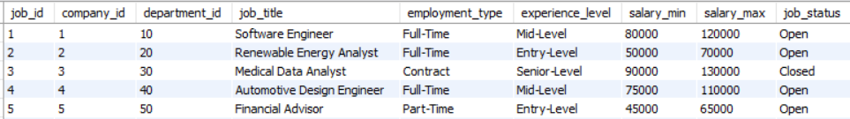

CREATE TABLE Job_Skill (
job_skill_id INT PRIMARY KEY,
job_id INT NOT NULL,
skill_id INT NOT NULL,
requirement_type VARCHAR(50),
min_proficiency_id INT NOT NULL,
FOREIGN KEY (job_id) REFERENCES Job(job_id),
FOREIGN KEY (skill_id) REFERENCES Skill(skill_id),
FOREIGN KEY (min_proficiency_id) REFERENCES Proficiency_Level(proficiency_id)
);
INSERT INTO Job_Skill (job_skill_id, job_id, skill_id, requirement_type, min_proficiency_id) VALUES
(1, 1, 101, 'Required', 3),
(2, 1, 102, 'Preferred', 2),
(3, 2, 103, 'Required', 2),
(4, 3, 104, 'Required', 3),
(5, 4, 105, 'Preferred', 2);
SELECT * FROM Job_Skill;
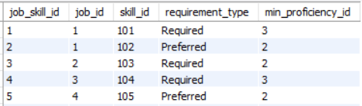

CREATE TABLE Job_Match (
match_id INT PRIMARY KEY,
employee_id INT NOT NULL,
job_id INT NOT NULL,
overall_match_score INT CHECK (overall_match_score BETWEEN 0 AND 100),
required_skills_matched INT,
required_skills_total INT,
FOREIGN KEY (employee_id) REFERENCES Employee(employee_id),
FOREIGN KEY (job_id) REFERENCES Job(job_id)
);
INSERT INTO Job_Match (match_id, employee_id, job_id, overall_match_score, required_skills_matched, required_skills_total) VALUES
(1, 101, 1, 85, 8, 10),
(2, 102, 2, 72, 6, 8),
(3, 103, 3, 90, 9, 10),
(4, 104, 4, 65, 5, 8),
(5, 105, 5, 78, 7, 9);
SELECT * FROM Job_Match;\
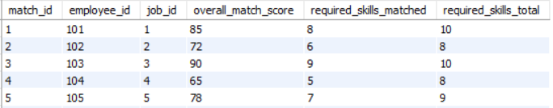

CREATE TABLE Application (
application_id INT PRIMARY KEY,
job_id INT NOT NULL,
employee_id INT NOT NULL,
match_id INT UNIQUE,
application_status VARCHAR(50),
applied_at DATE,
FOREIGN KEY (job_id) REFERENCES Job(job_id),
FOREIGN KEY (employee_id) REFERENCES Employee(employee_id),
FOREIGN KEY (match_id) REFERENCES Job_Match(match_id)
);
INSERT INTO Application (application_id, job_id, employee_id, match_id, application_status, applied_at) VALUES
(1, 1, 101, 1, 'Submitted', '2024-01-15'),
(2, 2, 102, 2, 'Under Review', '2024-02-10'),
(3, 3, 103, 3, 'Accepted', '2024-01-20'),
(4, 4, 104, 4, 'Rejected', '2024-02-05'),
(5, 5, 105, 5, 'Withdrawn', '2024-01-30');
SELECT * FROM Application;
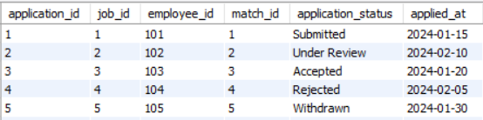

CREATE TABLE Notification (
notification_id INT PRIMARY KEY,
recipient_employee_id INT NOT NULL,
notification_type VARCHAR(50),
message VARCHAR(255),
is_read BOOLEAN DEFAULT FALSE,
FOREIGN KEY (recipient_employee_id) REFERENCES Employee(employee_id)
);
INSERT INTO Notification (notification_id, recipient_employee_id, notification_type, message, is_read) VALUES
(1, 101, 'Application Update', 'Your application status has been updated.', FALSE),
(2, 102, 'New Job Match', 'A new job matches your skills.', TRUE),
(3, 103, 'Skill Endorsement', 'Your skill has been endorsed by a colleague.', FALSE),
(4, 104, 'Interview Invitation', 'You have been invited for an interview.', FALSE),
(5, 105, 'System Alert', 'Your profile has been viewed by a recruiter.', TRUE);
SELECT * FROM Notification;
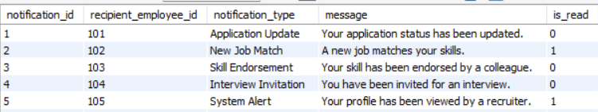

CREATE TABLE Skill_Verification_Request (
verification_request_id INT PRIMARY KEY,
employee_skill_id INT NOT NULL,
requester_employee_id INT NOT NULL,
manager_id INT NOT NULL,
request_status VARCHAR(50),
FOREIGN KEY (employee_skill_id) REFERENCES Employee_Skill(employee_skill_id),
FOREIGN KEY (requester_employee_id) REFERENCES Employee(employee_id),
FOREIGN KEY (manager_id) REFERENCES Employee(employee_id)
);
INSERT INTO Skill_Verification_Request (verification_request_id, employee_skill_id, requester_employee_id, manager_id, request_status) VALUES
(1, 1, 101, 102, 'Pending'),
(2, 2, 102, 101, 'Approved'),
(3, 3, 103, 102, 'Rejected'),
(4, 4, 104, 103, 'Completed'),
(5, 5, 105, 104, 'Pending');
SELECT * FROM Skill_Verification_Request;
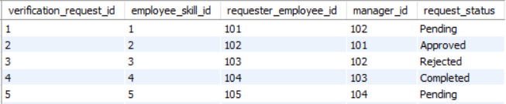

CREATE TABLE Skill_Market_Analytic (
analytics_id INT PRIMARY KEY,
skill_id INT NOT NULL,
analysis_period_start DATE,
analysis_period_end DATE,
total_job_postings INT CHECK (total_job_postings >= 0),
total_employees_with_skill INT CHECK (total_employees_with_skill >= 0),
supply_demand_ratio DECIMAL(5,2),
FOREIGN KEY (skill_id) REFERENCES Skill(skill_id)
);
INSERT INTO Skill_Market_Analytic (analytics_id, skill_id, analysis_period_start, analysis_period_end, total_job_postings, total_employees_with_skill, supply_demand_ratio) VALUES
(1, 101, '2024-01-01', '2024-03-31', 150, 45, 0.30),
(2, 102, '2024-01-01', '2024-03-31', 120, 30, 0.25),
(3, 103, '2024-01-01', '2024-03-31', 80, 25, 0.31),
(4, 104, '2024-01-01', '2024-03-31', 95, 20, 0.21),
(5, 105, '2024-01-01', '2024-03-31', 200, 50, 0.25);
SELECT * FROM Skill_Market_Analytic;
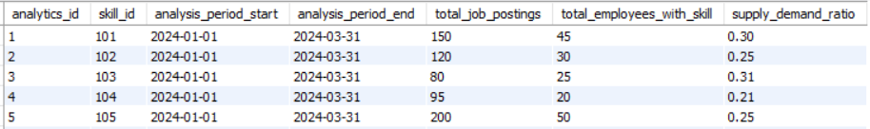

Part III
1.Write an SQL statement that lists all columns from one of your tables. Use sorting to sort the results using a numeric column in descending order.
SELECT *
FROM Job
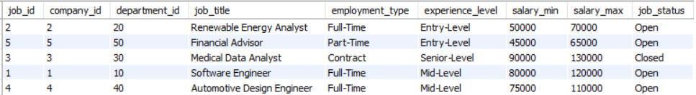
ORDER BY salary_max DESC;

2. Write THREE SQL queries that find stats from tables using min, max, average, and count functions. SELECT
MIN(total_experience_years) AS min_experience,
MAX(total_experience_years) AS max_experience,
AVG(total_experience_years) AS avg_experience
FROM Employee;
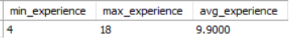
SELECT
MIN(salary_min) AS lowest_salary,
MAX(salary_max) AS highest_salary,
AVG(salary_min) AS average_min_salary
FROM Job;
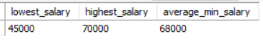
SELECT
COUNT(*) AS total_applications
FROM Application;
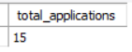
3. Write an SQL statement that uses Group By and find an average of a numeric column in groups.
SELECT
department_id,
AVG(total_experience_years) AS avg_experience_years
FROM Employee
GROUP BY department_id;
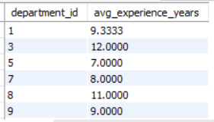
4. Write an SQL statement that utilises nested queries to select several columns from two tables with a relationship between them.
SELECT
employee_id,
full_name,
email
FROM Employee
WHERE employee_id IN (
SELECT employee_id
FROM Application
); 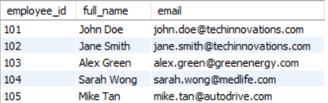

5. Write TWO SQL queries for showing A) a cartesian product of two tables' tuples and
SELECT
Employee.employee_id,
Employee.full_name,
Department.department_name
FROM Employee, Department;
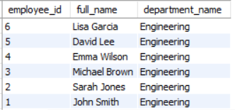
B) Without Cartesian Product (Using JOIN)
SELECT
e.employee_id,
e.full_name,
d.department_name
FROM Employee e
JOIN Department d
ON e.department_id = d.department_id;
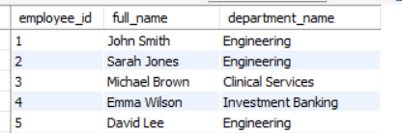

Critical Analysis and Redesign for Multi-User Environment
The current ER design models the domain well by identifying key entities such as Employee, Skill, Job, Application, and Company, and it correctly resolves many-to-many relationships using associative entities like Employee_Skill and Job_Skill. This makes the schema logically correct and suitable for relational implementation.
However, for a multi-user environment, several design issues exist.
First, some entities mix different responsibilities (e.g., employee data, verification, endorsements, and requests), which increases coupling and makes the schema harder to maintain as the number of users grows.
Second, the design lacks clear separation of roles (employee, manager, verifier), which is important when many users interact with the same data in different ways.
Third, some attributes are derived or redundant (e.g., match scores, total experience, matched skills), which can lead to inconsistency when multiple users update related data.
Redesign Improvements
- Further normalize the schema by separating role-specific data and process-specific entities (e.g., verification, endorsement, application status).
- Introduce role entities and relationships to clearly define user responsibilities and interactions.
- Remove or minimize derived attributes and calculate them when needed to avoid inconsistencies.

